**DOM XSS (Cross Site Scripting) in chrome**

1. Open google.com or any other site

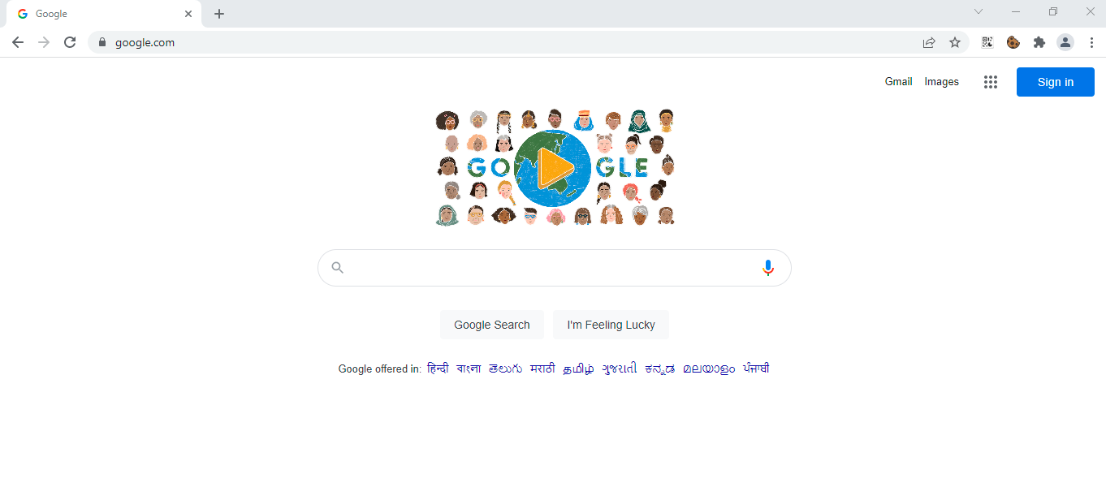

1. Enter payload in URL bar

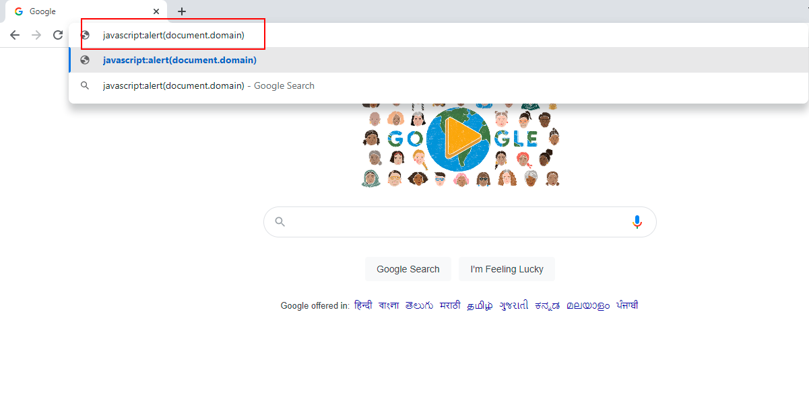

1. Observe that payload is executed

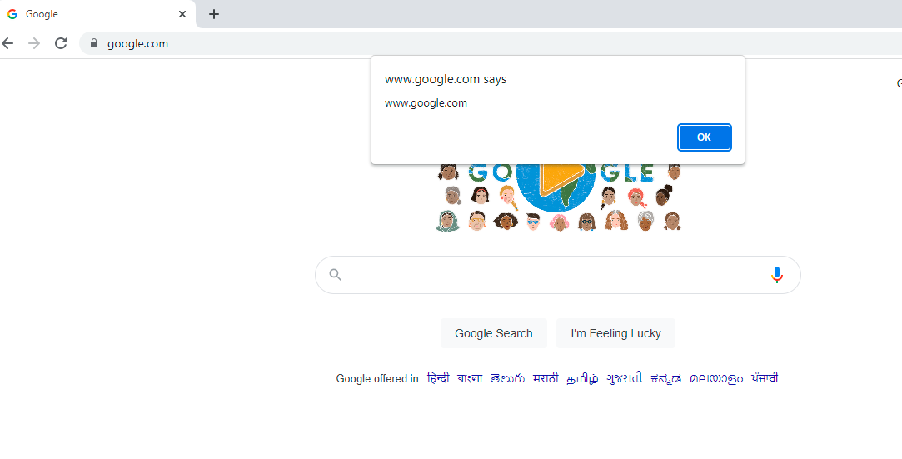

**Observations:**

Pasting of payload (javascript) is not allowed so it is hard to exploit. For this attacker has to trick the victim to type “j” and then to paste rest of the payload “avascript:alert(document.domain)” or any other payload.